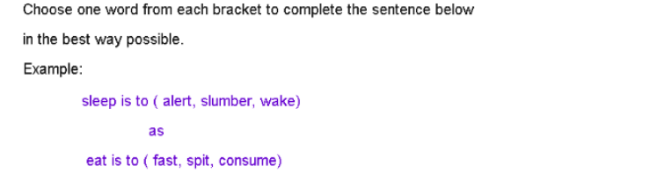
1. fiction is to (read / fabrication / facts)
as
non-fiction is to ( accurate / story / memories)

2. shriek is to ( laugh / whisper / screech)
as
whimper is to ( weak / whinge / cry )

3. bee is to (hive / swarm / honey)
as
lion is to (growl / mane / pride)

4. snake is to (slither / venom / long)
as
snail is to (shell / crawl / track)

5. snow is to ( winter / cold / flakes)
as
humid is to (sun / sticky / hot)

6. farm is to (goat / milk / ranch)
as
jungle is to (bush / elephant / stream)

7. car is to (path / road / water)
as
train is to (track / station / footpath)

Need more practice? Why not try our FREE sample Online papers.
https://smart-stepz.com/free-learning-resources/

