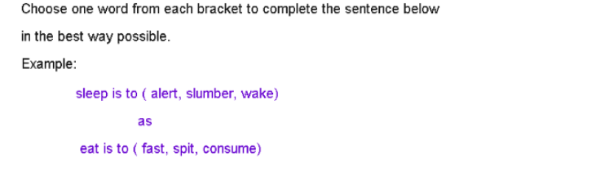
1. fiction is to (read / fabrication / facts)
as
non-fiction is to ( accurate / story / memories)

abrication and accurate
Fiction is a story that is fabricated ( made up) while non fiction is information based on facts so is accurate.

2. shriek is to ( laugh / whisper / screech)
as
whimper is to ( weak / whinge / cry )

screech and whinge
shriek = screech = a high-pitched scream
whimper = whinge = low, feeble sound
3. bee is to (hive / swarm / honey)
as
lion is to (growl / mane / pride)

swarm and pride
A large number of bees is called a swarm and a large number of lions is called a pride.

4. snake is to (slither / venom / long)
as
snail is to (shell / crawl / track)

slither and crawl
Snakes slither when they move while snails crawl when they move.

5. snow is to ( winter / cold / flakes)
as
humid is to (sun / sticky / hot)

flakes and sticky
Synonyms: snow= flakes humid = sticky

6. farm is to (goat / milk / ranch)
as
jungle is to (bush / elephant / stream)

ranch and bush
A synonym for farm is ranch while a synonym for jungle is bush.

7. car is to (path / road / water)
as
train is to (track / station / footpath)

road and track
A car is driven on a road while a train is run on a track.

Need more practice? Why not try our FREE sample Online papers.
https://smart-stepz.com/free-learning-resources/

