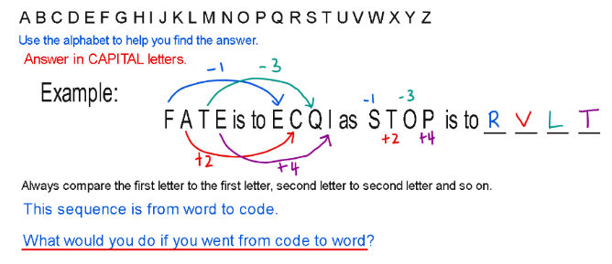
- If CAP is represented by FDS,What does FRZ represent?

- If AGENT is represented by CIGPV, how should GUEST be represented?

- If COLLECT is represented by BPKMDDS, how is RECEIVE represented?

- If GREEN is represented by FSDFM, what does FSDZ represent?

- If RACE is represented by SCFI, what does XQUH represent?

- If SALT is represented by TYOP, how should GIRL be represented?

Need more practice? Why not try our FREE sample Online papers.
https://smart-stepz.com/free-learning-resources/

