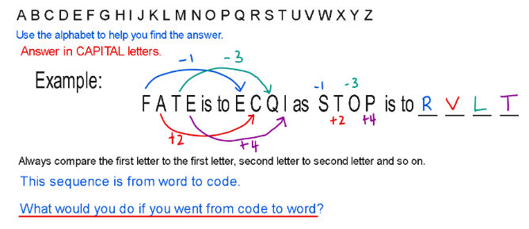
- If CAP is represented by FDS, what does FRZ represent?

(C to F = +3). ( A to D = +3). (P to S = +3)
To find word from code, we do the reverse pattern
F - 3 = C
R - 3 = O
Z - 3 = W

- If AGENT is represented by CIGPV, how should GUEST be represented?

(A to C = +2), (G to I= +2) (E to G= +2), (N to P= +2), (T to V= +2)
Since we need to create a code for the name, then:
G + 2 = I, U + 2 = W, E + 2 = G, S + 2 = U, T + 2 = V (IWGUV)

- If COLLECT is represented by BPKMDDS, how is RECEIVE represented?

(C to B = -1), (O to P= +1) (L to K= -1), (L to M= +1), (E to D= -1), (C to D= +1), (T to L= -1)

Since we need to create a code for the name, then:
R - 1 = Q, E + 1 = F, C- 1 = B, E + 1 = F, I - 1 = H, V + 1 = W, E - 1 = D
( QFBFHWD)

- If GREEN is represented by FSDFM, what does FSDZ represent?

(G to F = -1), (R to S= +1), (E to D= -1), (E to F= +1), (N to M= -1)

Code to word ( opposite)
F + 1 = G, S- 1 = R, D + 1 = E, Z - 1 = Y (GREY)

- If RACE is represented by SCFI, what does XQUH represent?

(R to S = +1), (A to C= +2), (C to F = +3), (E to I = +4)

Code to word ( opposite)
(X-1 = W), (Q- 2 = O), ( U - 3 = R) , ( H - 4 = D) (WORD)

- If SALT is represented by TYOP, how should GIRL be represented?

(S to T = +1), (A to Y= -2), (L to O= +3), (T to P= -4)

Since we need to create a code for the name, then:
(G + 1 = H),( I-2 = G),( R + 3 = U), (L - 4 = H) (HGUH)

Need more practice? Why not try our FREE sample Online papers.
https://smart-stepz.com/free-learning-resources/

