**Sequences**

**Select the image from the options which will continue the same sequence established by the five figures shown in each question**

1.

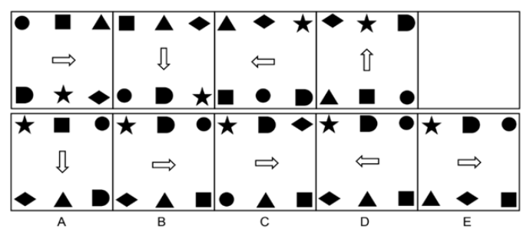

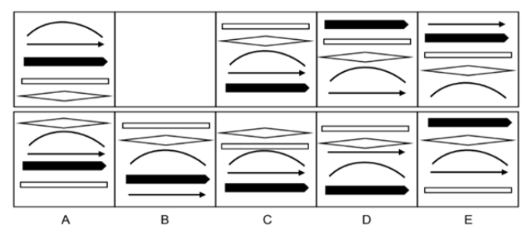2.

3.

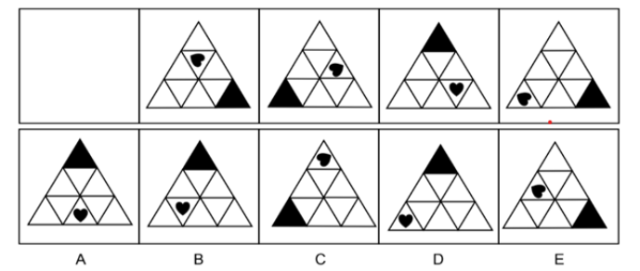

4.

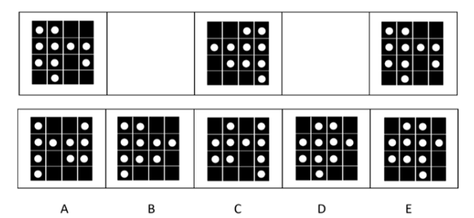

5.

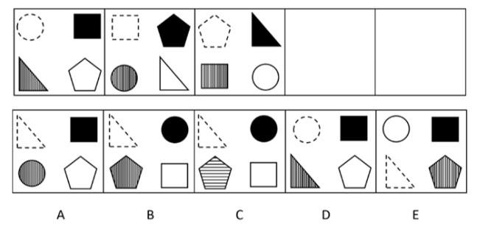

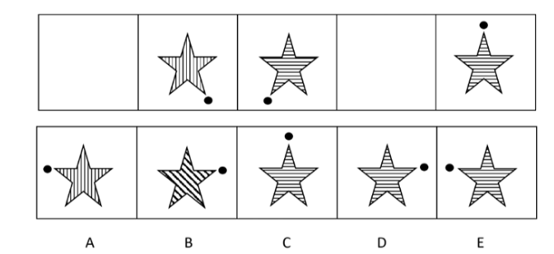6.

**Need more practice? Why not try our FREE sample Online papers.**

<https://smart-stepz.com/free-learning-resources/>