Roatations
Only ONE of the five figures on the right of the dotted line can be rotated to make the figure on the left. Choose which figure can be rotated.
1.
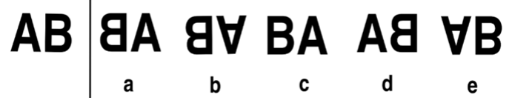
2.
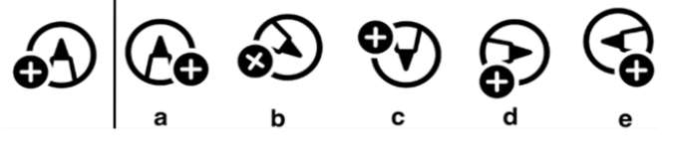
3.
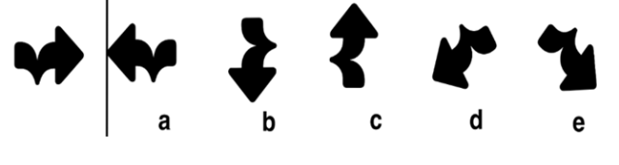

4.
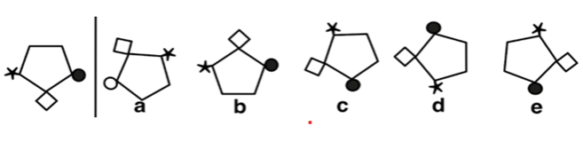

5.
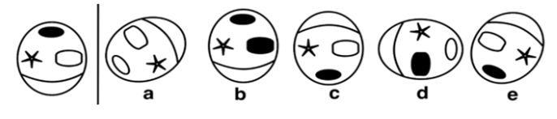

6.
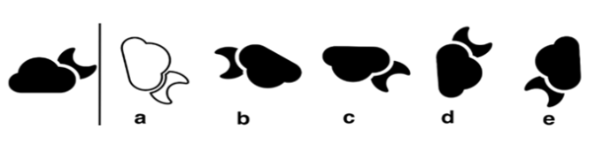
Need more practice? Why not try our FREE sample Online papers.
https://smart-stepz.com/free-learning-resources/

