1.
2.
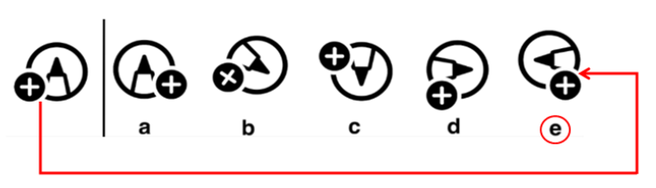
3.
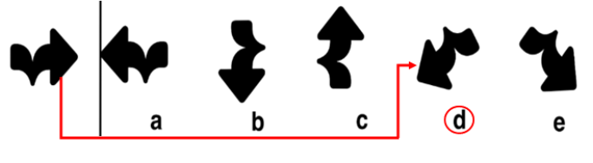

4.
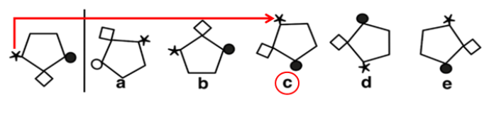
5.
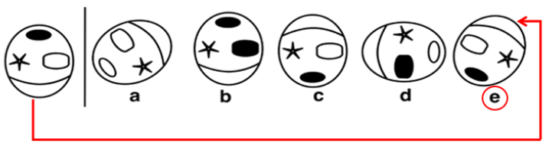

6.
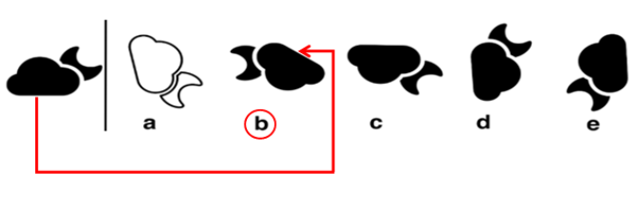
Need more practice? Why not try our FREE sample Online papers.
https://smart-stepz.com/free-learning-resources/

