Reflections
Choose which one of the figures to the right of the broken line is a mirror reflection of the figure on the left.

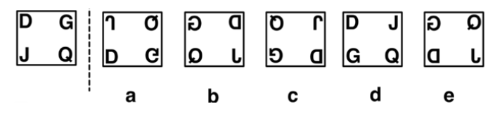
1.
2.
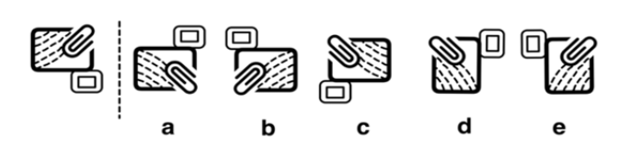

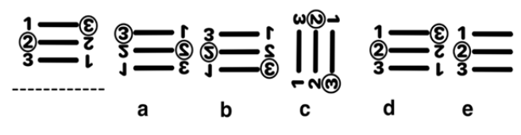
3.
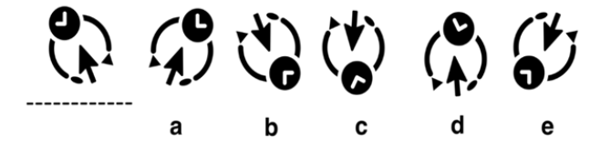
4.

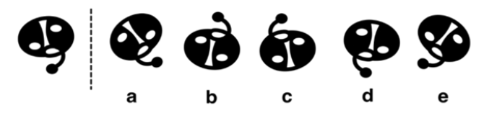
5.
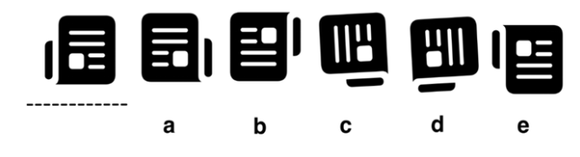
6.

Need more practice? Why not try our FREE sample Online papers.
https://smart-stepz.com/free-learning-resources/

