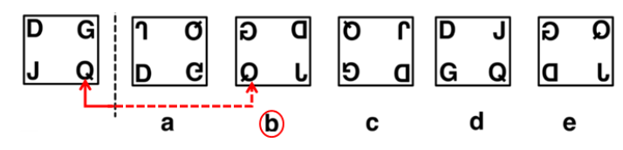
1.

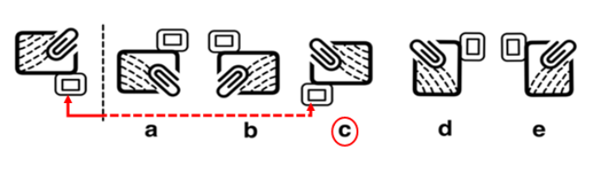
2.
3.
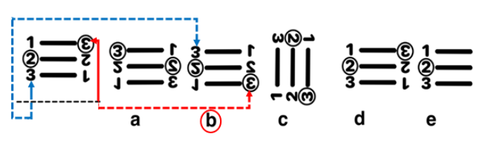

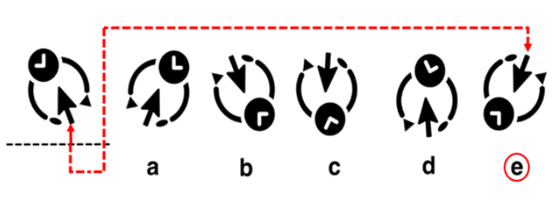
4.

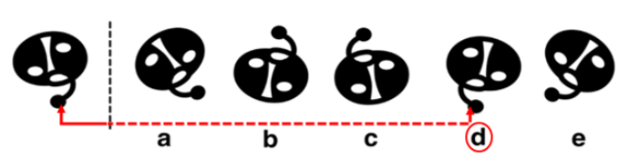
5.

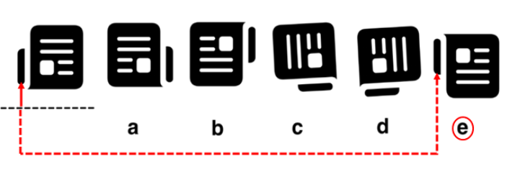
6.

Need more practice? Why not try our FREE sample Online papers.
https://smart-stepz.com/free-learning-resources/

