Paper 6 - Questions
- On a farm, the ratio of cattle to goat is 4 : 3 and the ratio of cattle to hens is 2 : 7. If there are 105 animals of these three types in the farm, find the number of goats and hens respectively.

- 20 , 15
- 15 , 20
- 15 , 70
- 70 , 15

- Jake, Blake and Kiran are friends. The ratio of their heights is 4 : 6 : 7. If Jake’s height 140 cm, what is the height of Kiran?

- 245 cm
- 35 cm
- 210 cm
- 140 cm

- Evaluate, √100 - √64

- 10
- 2²
- 2
- 36

- The actual length of stream is 250 m. On a map, the same stream has been drawn on a scale of 1 : 10 000. What is the length of the stream on the map?

  - 2500 m
  - 2.5 m
  - 2.5 cm
  - 25 cm

- Underline the answer which represents the angles in a quadrilateral.
  - 90° , 110° , 100° , 70°
  - 65° , 100° , 115° , 80°
  - 65° , 90° , 105° , 85°
  - 110° , 110° , 80° , 70°

- The pie chart shows the percentage of children in KS1 who voted for their favourite fruits.
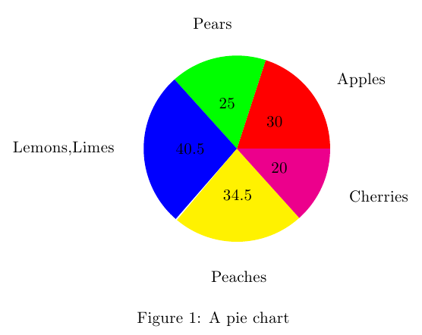
If there are 200 students, how many students chose peaches as their favorite fruit?
- 69
- 52
- 60
- 4

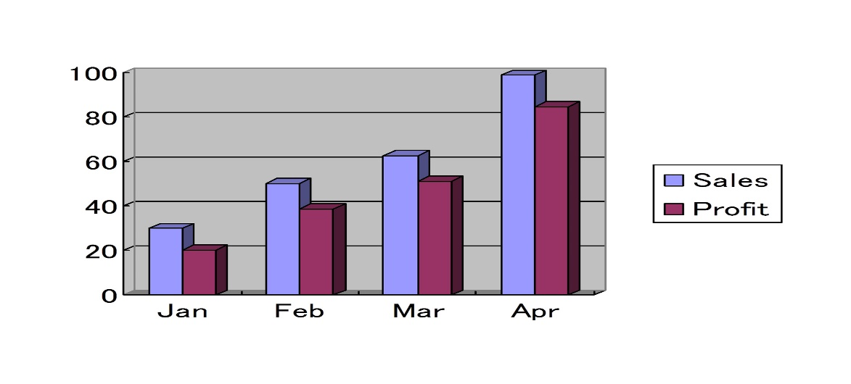
The bar graph shows the percentages of the sales and the profit of a company. According to the graph, how much more profit was made in March then in January?
- 10%
- 25%
- 30%
- 50%

- If the general term of a certain number pattern is 2n – 1, what is the 72nd term of this number pattern?
  - 143
  - 144
  - 145
  - 142

- The following figure shows how some sticks were arranged for an assessment activity,
c
a

b

According the above pattern, select the next shape of this pattern

- A lorry had to make 7 trips in order to transport sand with a of mass 66.5 t. If the lorry carried an equal amount of sand on each trip, what is the mass of the sand it carried on one trip?
  - 95 t
  - 0.95 t
  - 9.5 t
  - 950 t

Need more practice? Why not try our FREE sample Online papers.
https://smart-stepz.com/free-learning-resources/

