Paper 5- Questions
- What is the area of the compound shape?

- 75 cm²
|
- 50 cm²
4 cm
- 60 cm²
5 cm
- 100 cm²
|
10 cm

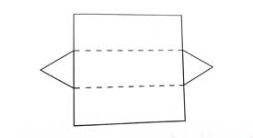
What is the name of the 3-D shape that can be made from this net?

- Square pyramid
- Triangular Prism
- Rectangular Prism
- Cube Prism

- In a bag, there are 4 red balls, 5 blue balls and 2 green balls which are identical in all aspects except the colour. What is the probability of a ball drawn from the bag being red?
  - 5/11
  - 4/11
  - 2/11
  - 7/11

- “All the angles in a rectangle and a square are ………………………”
- Acute angle
- Obtuse angle
- Straight angle
- Right angle

- Simplify (+3) – (-5)
- +8
- -2
- +2
- -8

___
___
- Simplify, 15 5
÷
3 36
- 25
- 2.5
- 36
- 55

___________
- Simplify, (-12) × (4)
(-3) + (5)
- +24
- +16
- -24
- -16

- t is the value of x?
- 80°
- 25°
x + 25°
80°
- 55°
- 105°

- Using the weighing scale shown in the following figure, what is the value of x?
- 6
- 4
5
- 3
22
3x + 5
- 2

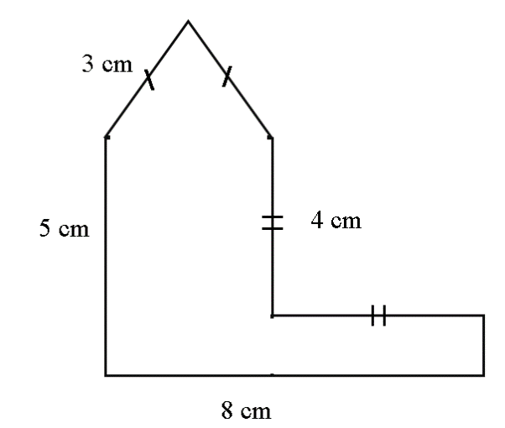

- Find the perimeter of the given figure,

- 24 cm
- 20 cm
- 28 cm²
- 28 cm

Need more practice? Why not try our FREE sample Online papers.
https://smart-stepz.com/free-learning-resources/

