Paper 4- Questions
- Below is a pie chart which shows the different products bought by customers at a local shop.
Pizza
30%
Pasta
10%
Hot dogs
10%
Cheese
25%
Chicken
25%

If 200 customers visited the shop, how many bought pizza?
- 300
- 60
- 30
- 6

- In a bag of fertilizer, the proportion of Sulphur to phosphorous is 5 : 2. If the mass of phosphorous in the bag is 300g, what is the mass of the whole bag?
- 150g
- 750g
- 1050g
- 900g

- Find the area of the shaded section
8 cm
6 cm
20 cm
14 cm
- 280 cm²
- 268 cm²
- 304 cm²
- 256 cm²

- The capacity of a water tank is 6000 l. After filling the tank completely, 800 l of water is used each day for four days and 1200 l of water is used each day for two days. Find the volume of water remaining after these 6 days.

- 400 l
- 3200 l
- 5600 l
- 2400 l

- What is the name of the 3_D shape which has four triangular faces and a square face?

- Cuboid
- Prism
- Square Pyramid
- Regular Icosahedron

- What is angle AôP ?

- 52°
Q
P
- 26°
- 130°
- 180°
O
B
A
50°

3x°

2x°

- The ratio of apples to oranges to bananas to all the Sainsbury stores is 5: 4 : 3. If the total number of apples, oranges and bananas delivered is 14 400, how many apples were delivered?

- 4800
- 8400
- 6000
- 10 800

- Jack walked from a point A to the point B as shown in the figure. How many times did he walk in an easterly direction?

- Five
- Three
- Nine
- Six
>
B
A

>

- If a man saves 15% of his monthly salary of £2000, much of money does he save?

- £ 350
- £ 300
- £ 220
- £ 120

- What percent of the shape is shaded?

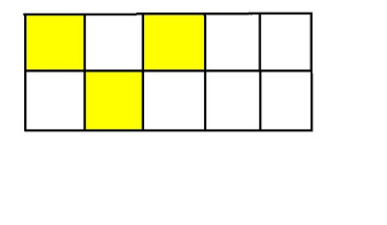
- 3%
- 30%
- 300%
- 50%

Need more practice? Why not try our FREE sample Online papers.
https://smart-stepz.com/free-learning-resources/

