Paper 3-Questions
- A vehicle travelled 20 km on 2 liters of fuel. How many liters of fuel are required to travel 160 km?
- 16 liters
- 8 liters
- 4 liters
- 10 liters

- Which of the numbers below is,

“Two hundred four million seven thousand eight hundred”?
- 20407800
- 240, 700, 800
- 20,400,7800
- 204, 007, 800

- How many groups of twenty-five are there in 1750?
- 70
- 10
- 75
- 80

- An express train took 2 hours 40 minutes and 10 seconds to travel from Manchester to Sheffield. A bus which left Manchester at the same took 4 hours 20 minutes and 25 seconds to reach Sheffield. How much time would a commuter save travelling by train instead of by bus?
- 1 hour 80 minutes and 1 seconds
- 1 hour 10 minutes and 45 seconds
- 1 hour 40 minutes and 15 seconds
- 2 hours 40 minutes and 15 seconds

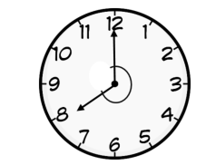
- What is the outer angle made by the hour and minute hand?
- Acute angle
- Reflex angle
- Obtuse angle
- Right angle

- How many lines of symmetry are there in the given figure?
- 3
- 4
- 5
- 6

- Find the answer for the following expression,
8 + 5 × (10 + 2) ÷ 3 – 4
- 26
- 24
- 30
- 34

- Which net can be used to create a cube?

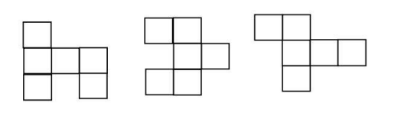
c.
b.
a.

- Express the statement below as an equation.

“When 12 is subtracted from five times a certain number, the value obtained is 98”
- 5 (x – 12) = 98
- 12 – 5x = 98
- 12 – x = 98
- 5x – 12 = 98

- Find the perimeter of the following figure,
- 24 cm
- 24 m
- 16 cm
- 16 m
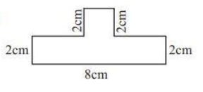

Need more practice? Why not try our FREE sample Online papers.
https://smart-stepz.com/free-learning-resources/

