- There are 32 students in Year 5.
3 in every 8 are boys. How many girls are in the class?
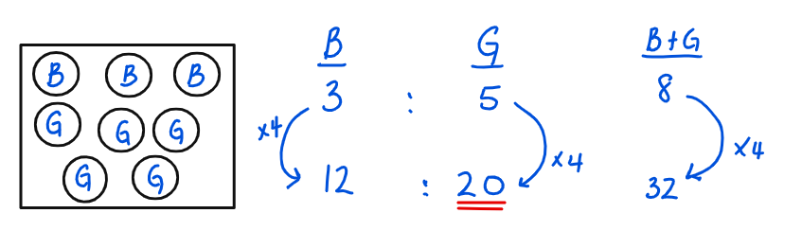

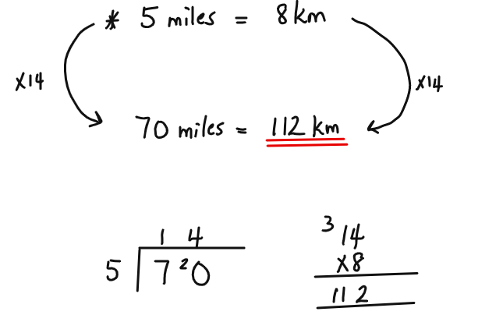
- The distance between two points is 70 miles. How many Km is this?

- A barrel holds 6L of liquid. 200ml of liquid leaks out every 5 minutes. How many minutes will it take for the barrel to be empty?
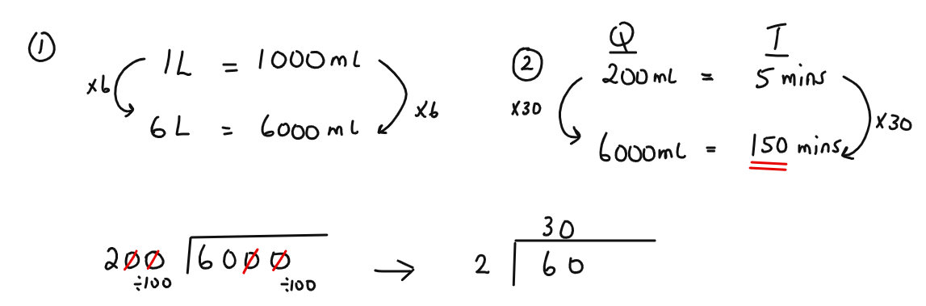

- What is 1/3 of a ¼ of ½ of 144?
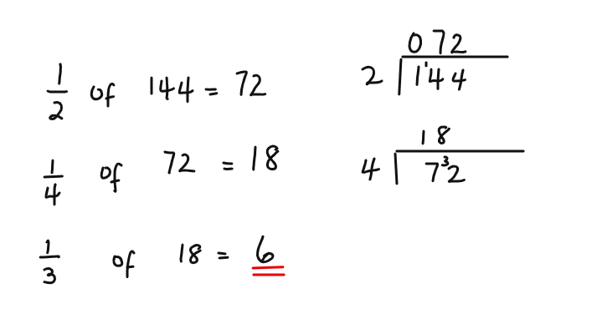

- The following are weights, in Kilograms, of students.

23 kg 26 kg 27kg 44 kg

39 kg 27 kg 38 kg

- What is the median weight?
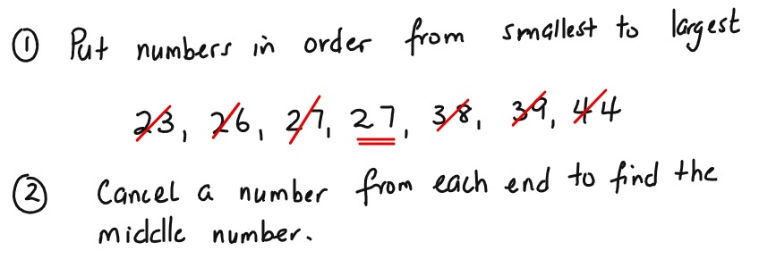

- What is the mean weight?
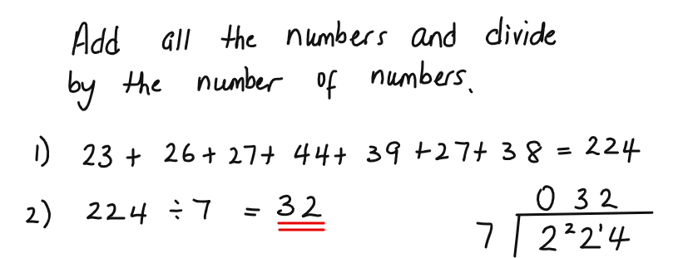

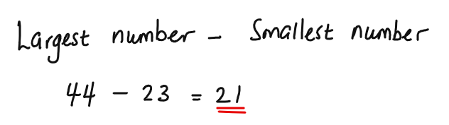
- What is the range of the weights?

- What is the mode of the weights?
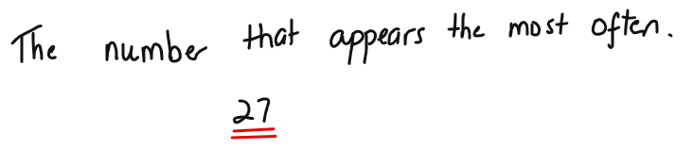

- Jimmy and Sophia are playing a numbers game.
Sophia thinks a number and then adds 35 to it. She multiplies the result by 4 and subtracts 7 from it.
Her final answer is 153.
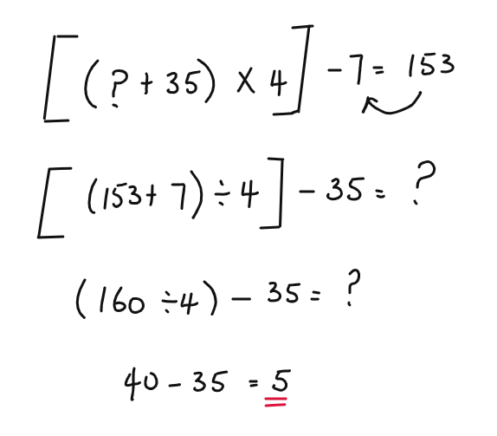
What number had Sophia thought of?

Need more practice? Why not try our FREE sample Online papers.
https://smart-stepz.com/free-learning-resources/

