Pairing images
There are 6 images in each table. Each image matches with another to make a pair. Find the 3 pairs of images from the 5 columns of options on the right.
1.
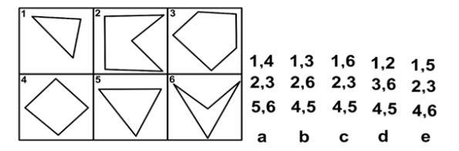

2.
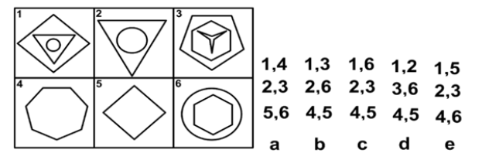

3.

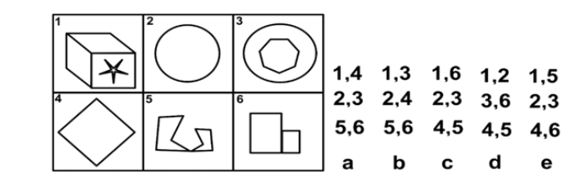

4.

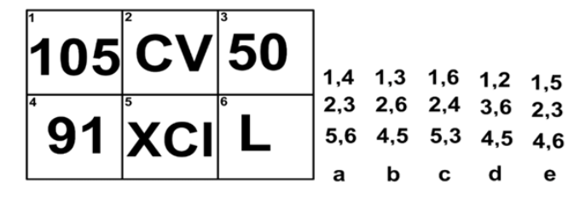

5.
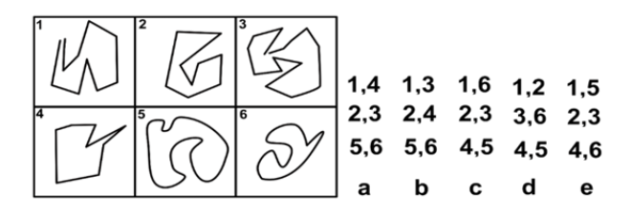

6.
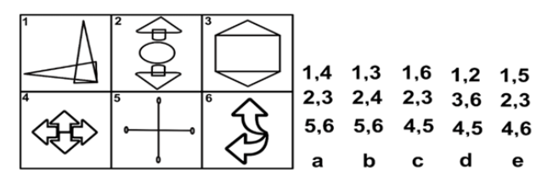

Need more practice? Why not try our FREE sample Online papers.
https://smart-stepz.com/free-learning-resources/

