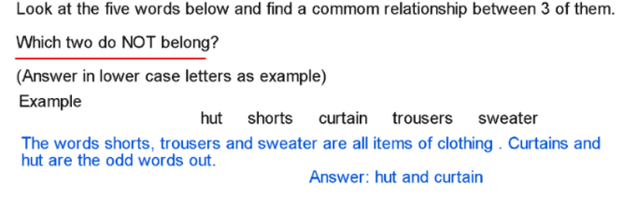

- ( lustrous prickly coarse luminous bristly )

lustrous and luminous = shiny
prickly, coarse and bristly = rough

- ( melancholy wistful cheerful dejected fortunate )

cheerful and fortunate = happy
melancholy, wistful and dejected = sad

- ( obedient enough clumsy seldom scrawny )

enough and seldom = adverbs
obedient, clumsy and scrawny = adjectives

- ( decagon sphere octahedron trapezium cone)

decagon and trapezium = 2D shapes
sphere, octahedron and cone = 3D shapes

- ( January April October September July )

April and September = 30 days
January, July and October = 31 days

- ( mozzarella ricotta skyr edam straggisto
skyr and straggisto
skyr = yoghurt from Iceland
straggisto = yoghurt from Greece
mozzarella, edam and ricotta = types of cheese

Need more practice? Why not try our FREE sample Online papers.
https://smart-stepz.com/free-learning-resources/

