Odd one out
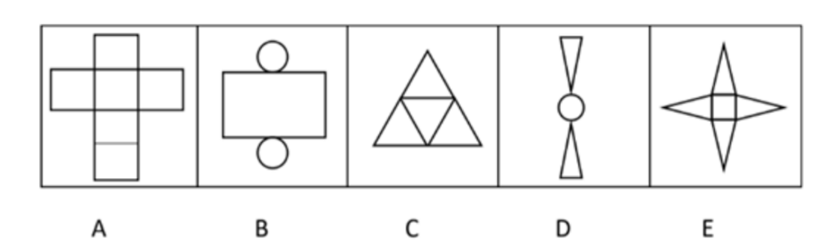
From the 5 images shown, choose the image that looks least like the other four.

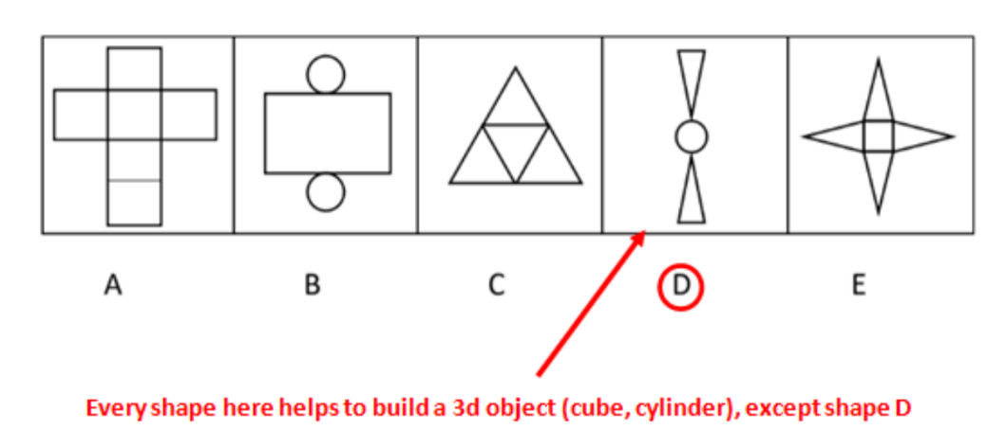

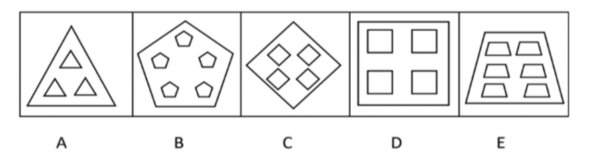
1.
2. 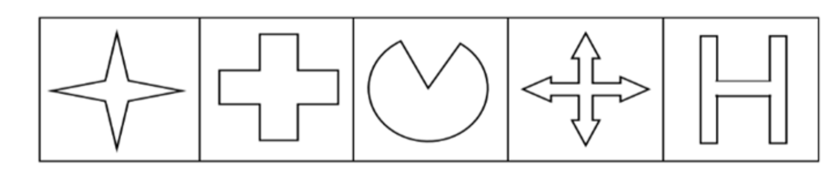
3.
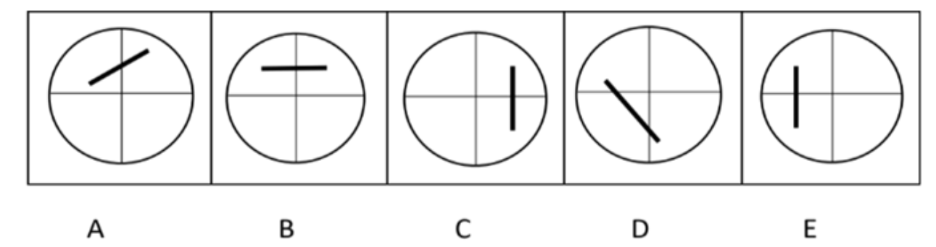
4.
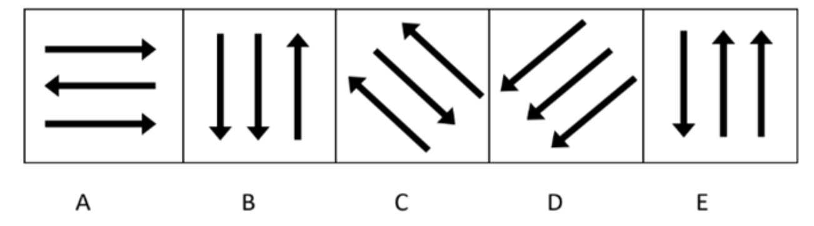
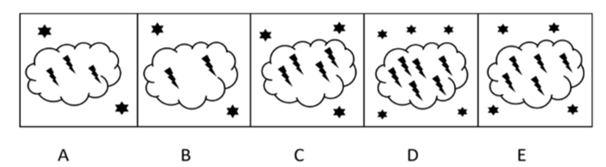
5.
6.
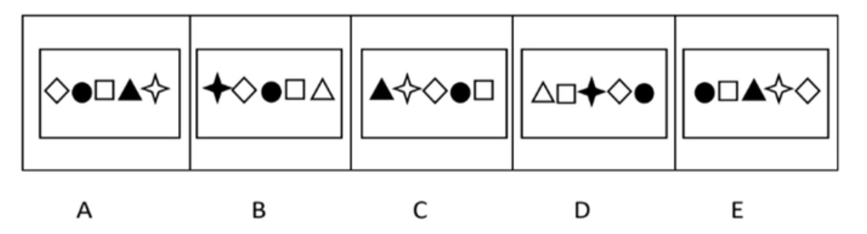

Need more practice? Why not try our FREE sample Online papers.
https://smart-stepz.com/free-learning-resources/

