Most Like
The 2 figures on the left are alike in some way. Choose which one of the 5 images on the right is most like the first two figures.

1.

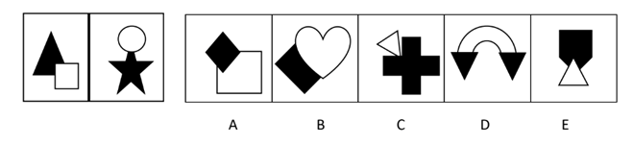2.
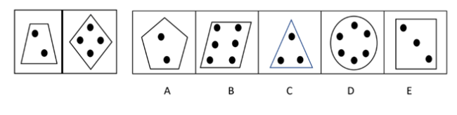
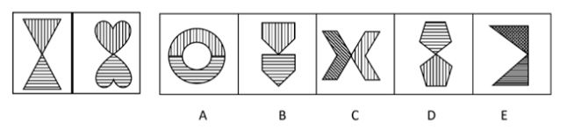
3.

4.
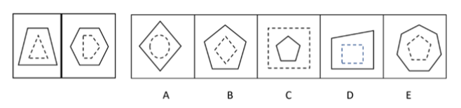
5.

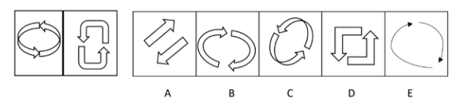
6.
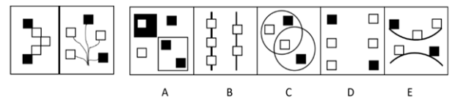

Need more practice? Why not try our FREE sample Online papers.
https://smart-stepz.com/free-learning-resources/

