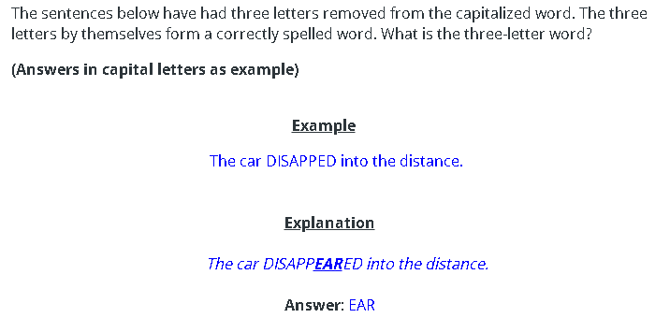

- The two boys were fishing for TR.

The two boys were fishing for TROUT.

- The wine spent many weeks FERTING.

The wine spent many weeks FERMENTING.

- HORS are very troublesome in summer.

HORNETS are very troublesome in summer.

- They climbed the SPEST hill.

They climbed the STEAPEST hill.

- He injured his SE in the accident.

He injured his SPINE in the accident.

- The girl’s behaviour APLED her teacher.

The girl’s behaviour APPALLED her teacher.

- She CED the dog to follow her.

She CALLED the dog to follow her.

Need more practice? Why not try our FREE sample Online papers.
https://smart-stepz.com/free-learning-resources/

