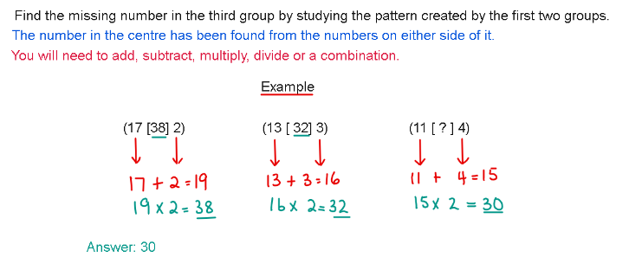

- (89 [ 38 ] 61) (77 [ 46 ] 41) (61 [ ? ] 13)

- ( 7 [ 77 ] 22 ) ( 69 [ 138 ] 4 ) ( 79 [ ? ] 6 )

- ( 42[ 45 ] 132 ) ( 31 [ 21 ] 73 ) ( 86 [ ? ] 124 )

- ( 96 [ 4 ] 12 ) ( 72 [ 9 ] 4 ) ( 84 [ ? ] 6 )

- (16 [ 48 ] 6 ) ( 34 [ 51 ] 3 ) ( 78 [ ? ] 3 )

- ( 84 [ 17 ] 7 ) ( 121 [ 16 ] 11 ) ( 213 [ ? ] 71 )

- (13 [ 55 ] 143) (18 [ 45 ] 162) (9 [ ? ] 72)

- ( 60 [ 25 ] 78 ) ( 27 [ 32 ] 52 ) ( 18 [ ? ] 82 )

- ( 90 [ 21 ] 30 ) ( 48 [ 28 ] 12 ) ( 45 [ ? ] 9 )

- ( 75 [ 58 ] 5 ) ( 67 [ 26 ] 29 ) ( 54 [ ? ] 18 )

Need more practice? Why not try our FREE sample Online papers.
https://smart-stepz.co.uk/online-learning-for-11-plus/#GetinTouch

