Matrices
Choose the correct option from A to E and determine which of the boxes would best complete the grid of squares.
1.
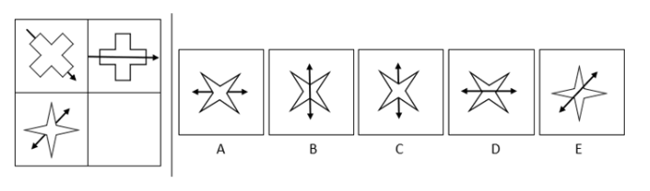
2.
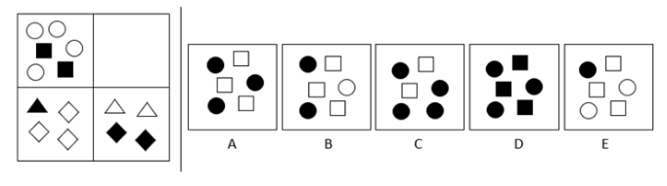
3.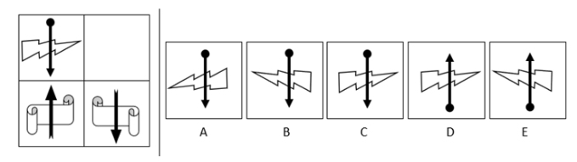

4.
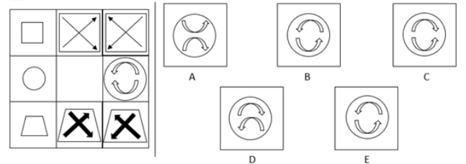
5.
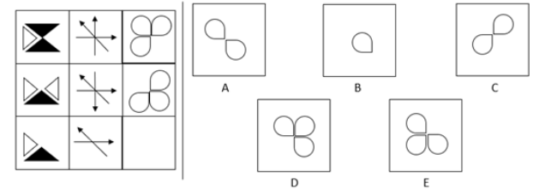
6.
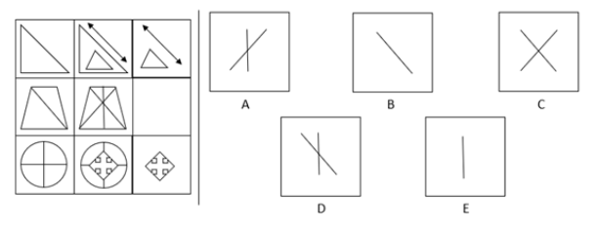
Need more practice? Why not try our FREE sample Online papers.
https://smart-stepz.com/free-learning-resources/

