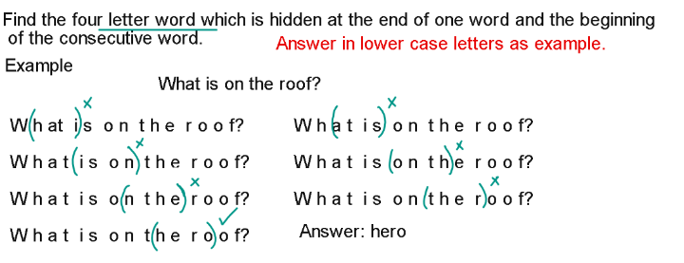
- Can you please amuse the guests while I make coffee?

- The rocks rolled down the steep slope slowly.

- Why do patients look pale after surgery?

- The young nun prayed for her.

- Were the men early for church?

- All the students went out to play.

- Remove all cobwebs from your imagination.

Need more practice? Why not try our FREE sample Online papers.
https://smart-stepz.com/free-learning-resources/

