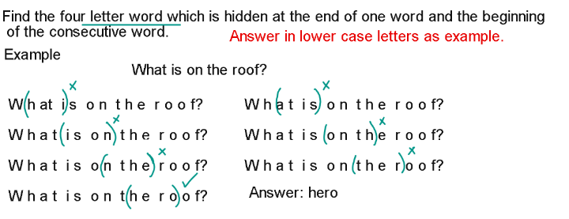
- Can you please amuse the guests while I make coffee?
seam
Can you please amuse the guests while I make coffee?

- The rocks rolled down the steep slope slowly.
hero
The rocks rolled down the steep slope slowly.

- Why do patients look pale after surgery?

leaf
Why do patients look pale after surgery?

- The young nun prayed for her.

they
The young nun prayed for her.

- Were the men early for church?
them/ near

Were the men early for church?
Were the men early for church?

- All the students went out to play.

tout
All the students went out to play.
tout = selling or advertising a product

- Remove all cobwebs from your imagination.

veal
Remove all cobwebs from your imagination.
veal = meat of a baby cow.

Need more practice? Why not try our FREE sample Online papers.
https://smart-stepz.com/free-learning-resources/

