Hidden Shapes
The shape on the left is hidden in one of the five shapes A-E. It’s exactly the same size and has NOT been rotated. Choose the image that contains the shape.
1.
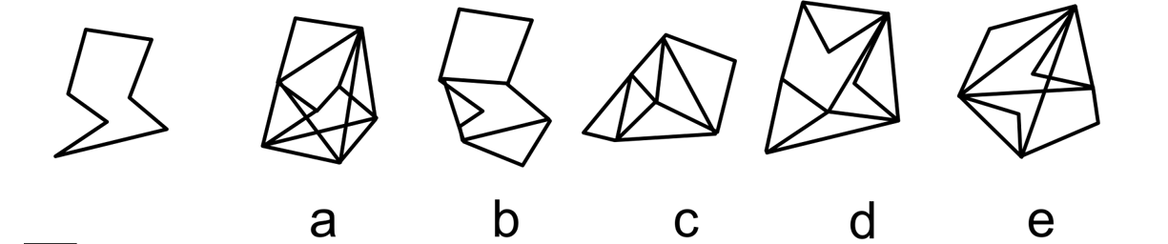

2.
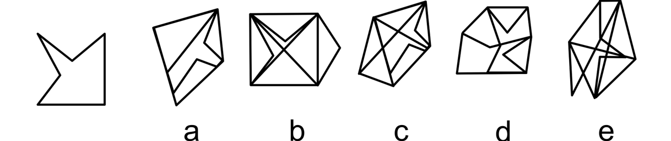

3.
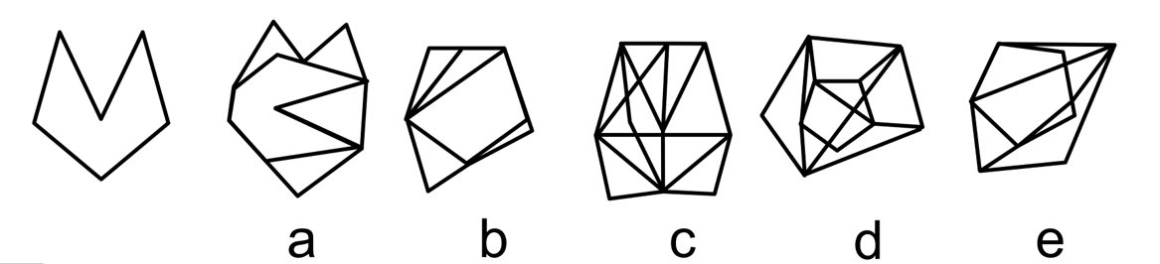
4.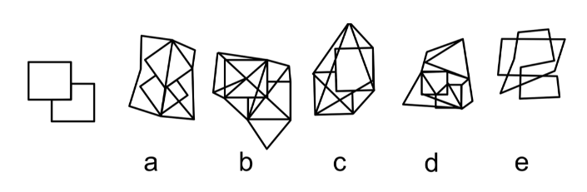
5.
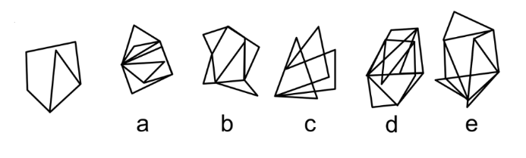
6.
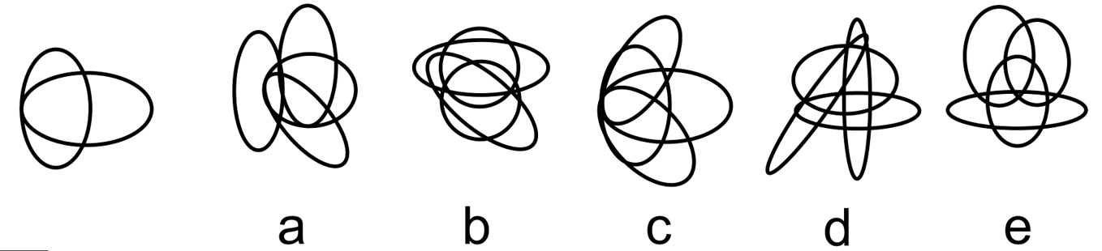

Need more practice? Why not try our FREE sample Online papers.
https://smart-stepz.com/free-learning-resources/

