1.

2.
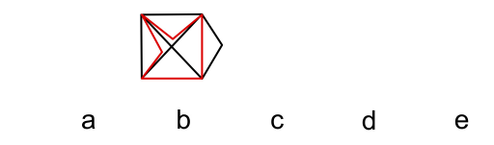

3.
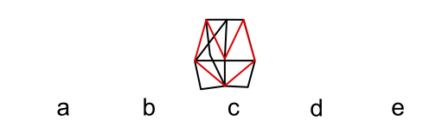

4.
5.
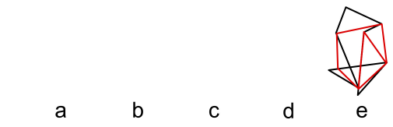
6.
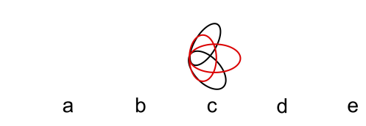

Need more practice? Why not try our FREE sample Online papers.
https://smart-stepz.com/free-learning-resources/

