B

Harry Potter and the Philosopher’s Stone
(Answers)
- D

- C

- D

- C

- D

- C

7)B
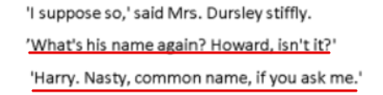

8)B

9)B

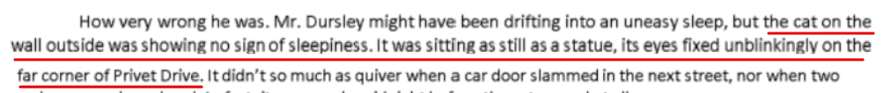
10)C

11)D

12) B

13)A - Called her “Mrs Next Door” because she didn’t know her by name.

14)B

15)D

16)D

17)D

18)A

19)A (Verb is a doing word)

20) B (Adjective describes the noun)

21)C (Adverb describes a verb – adverb usually ends in ‘ly’)

22)D ( Kent= Proper noun while Bird = common noun)

23)C (Conjunction= joining words that link together parts of a sentence)

24)D (Contractions = two words joined together)

25)B (Pronouns= replace a noun)

26) B(Preposition= describe position of something)

27) A – little

28) B- theatres’

29) C-weight

30) B-fierce

31) C-raised

32) D-though

33) D-laugh

34) D-excessive

35) D (B should have been a capital)

36) B (Should be a , after Asia)

37) A (P should have been lowercase)

38) N

39) D (Full stop after time)

40) B (, after forests)

41) D ( Capital O in occasionally)

42) B (; not needed)

43) C- several

44) D- regular

45) B- habits

46) A- affect

47) C- nutritious

48) B- Contrarily

49) C-favour

50) B-standard

Need more practice? Why not try our FREE sample Online papers.
https://smart-stepz.com/free-learning-resources/

