Folding Paper
For each question, how will the image on the left look when the transparent paper is folded upwards along the dotted line?
1.
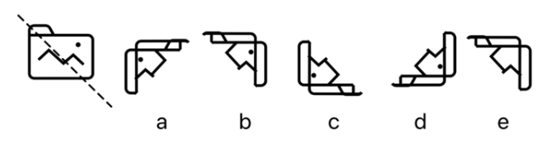
2.
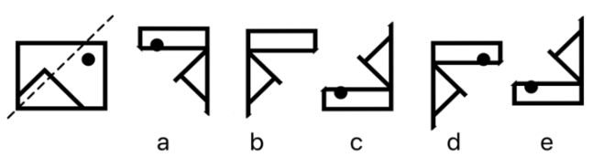
3.
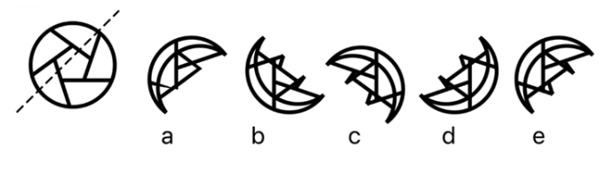

4.
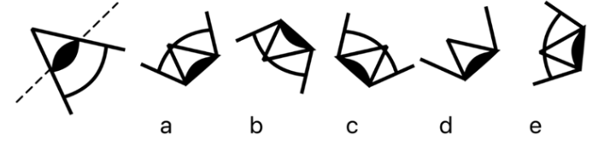

5.
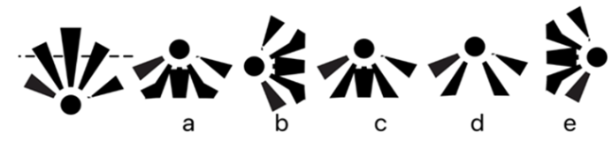

6.
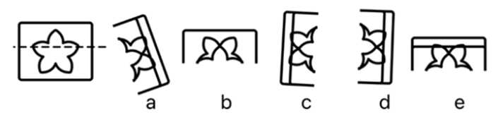

Need more practice? Why not try our FREE sample Online papers.
https://smart-stepz.com/free-learning-resources/

