1.
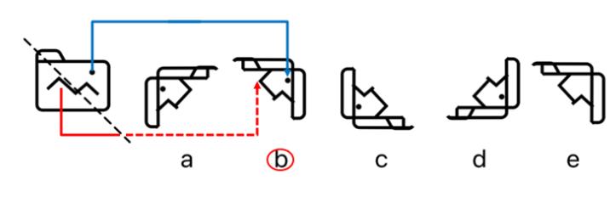
2.

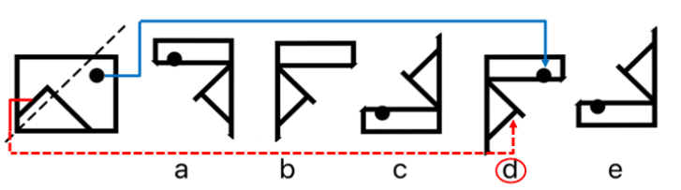
3
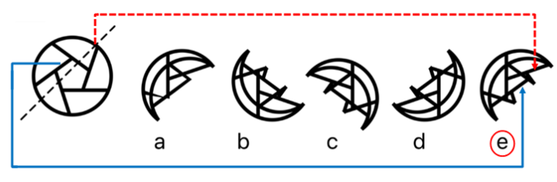
4.
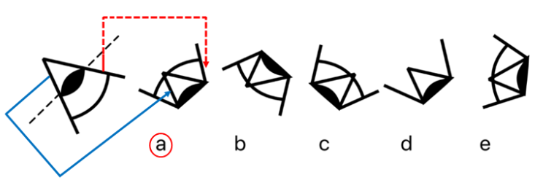
5.
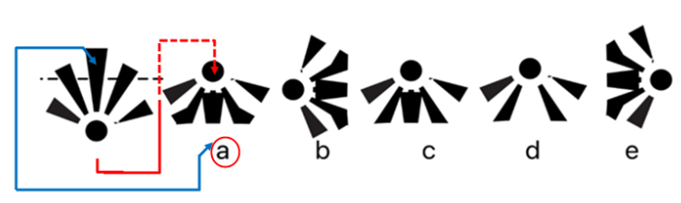
6.
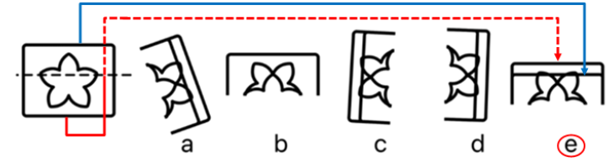
Need more practice? Why not try our FREE sample Online papers.
https://smart-stepz.com/free-learning-resources/

