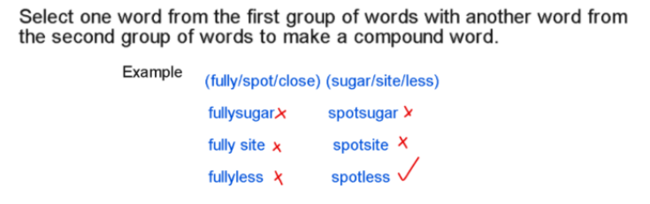
- (con / ant / car) (tip / ate / ton)

- (pan / disc / on) (all / take / over)

- (band / fact / pan ) (cage / try / edge)

- (jump / stop / band) (pit / star / age)

- (run, track, step) (stairs, away, stop)

- (he, she, the) (inch, not, me)

- (pup, sup, tar) (ton, pet, use)

Need more practice? Why not try our FREE sample Online papers.
https://smart-stepz.com/free-learning-resources/

