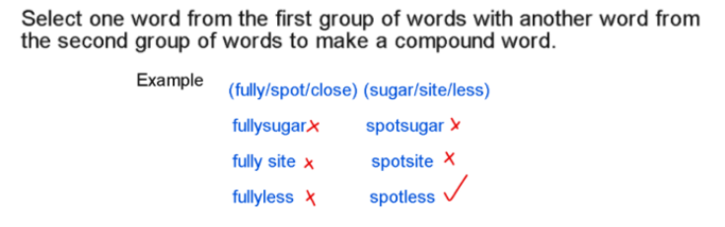
- (con / ant / car) (tip / ate / ton)

car + ton = carton

- (pan / disc / on) (all / take / over)

disc + over = discover

- (band / fact / pan ) (cage / try / edge)

pan + try = pantry

- (jump / stop / band) (pit / star / age)

band + age = bandage

- (run, track, step) (stairs, away, stop)

run + away = runaway

- (he, she, the) (inch, not, me)

the + me = theme

- (pup, sup, tar) (ton, pet, use)
pup + pet = puppet

Need more practice? Why not try our FREE sample Online papers.
https://smart-stepz.com/free-learning-resources/

