Coding
Work out the code for the first four figures and choose which of the given code is an accurate description of the fifth.
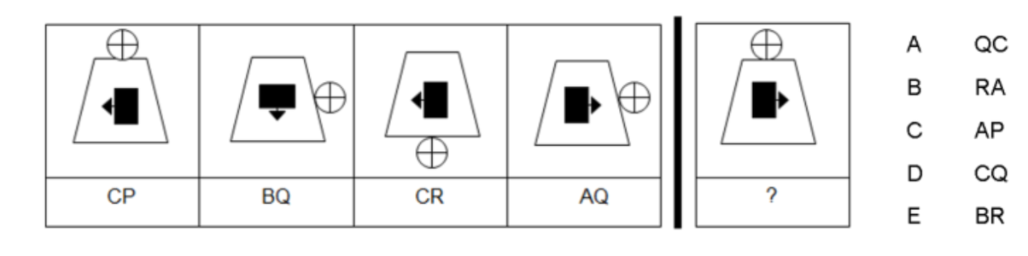
1.

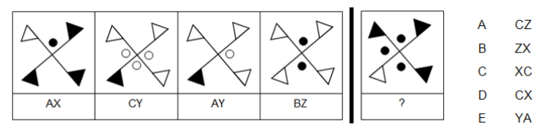
2.

3.
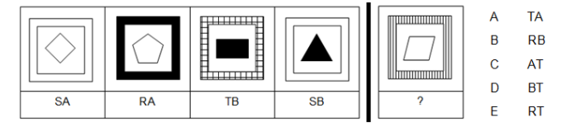

4.
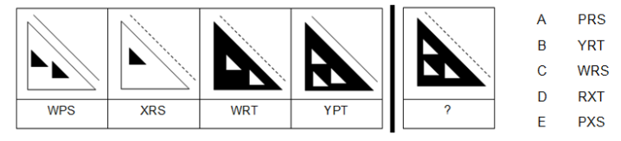
5.
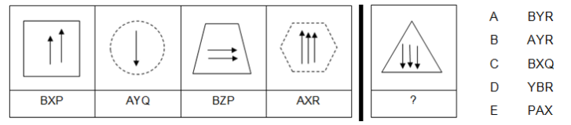
6.
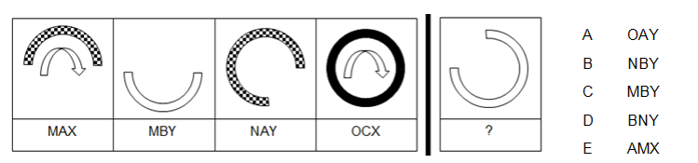

Need more practice? Why not try our FREE sample Online papers.
https://smart-stepz.com/free-learning-resources/

