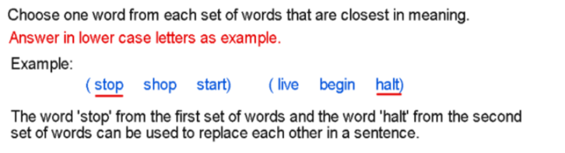
- (vessel sink active) (basin sea weary)

sink and basin = a round wide container open at the top

- (sharp wound benefit) (insult knife catch)

wound and insult = an injury to a person's feelings/reputation

- (wage agile adopt) (nimble abandon owe)

agile and nimble = able to move quickly and easily

- (loose royal dismayed) (pale spade ruffled)

dismayed and ruffled = feeling angry, frustrated or unhappy

- (bushel race dual) (game hoard witty)

bushel and hoard = a large number of something

- (feed flower player) (spring nourish grass)

feed and nourish = to provide with food

- (clown plan blossom) (attack flourish time)

blossom and flourish = to grow or develop quickly and in a
healthy way

Need more practice? Why not try our FREE sample Online papers.
https://smart-stepz.com/free-learning-resources/

