Paper 2-Answers
- What is 3² × 2³?
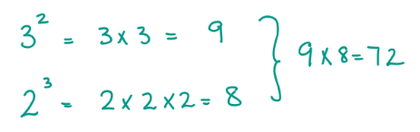

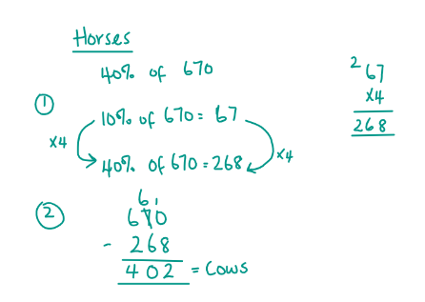
- A farmer has 670 animals. 40% of these animals are horses while the rest are cows. How many cows does the farmer have?

- The temperature in Doha is 11⁰C. In Nairobi, it is twice as much and in Marseille, the temperature is 5⁰C more than Nairobi. What is the temperature in Marseille?

- A barrel holds 6 litres of liquid. 200ml of liquid leaks out every 5 minutes. How many minutes will it take for the barrel to be empty?
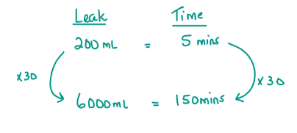

- Calculate the area of the compound shape below.
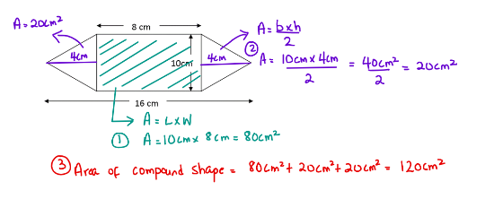

- Steve has £35 savings in a local bank. In this bank, all savings earn 5% interest on the balance per month. How much will Steve’s savings be at the end of 3 months? (Provide your answer to 2 decimal points)
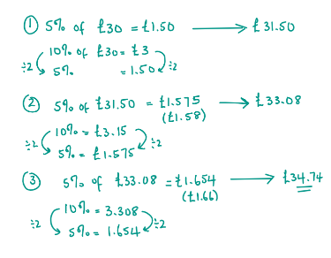

7. What is the value of k in the following equation?
12k – 16 = 20k – 80
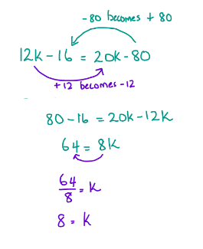

8. The pie chart below shows the number of balls in a bucket. How many white balls are in the bucket if the total number of balls are 150?
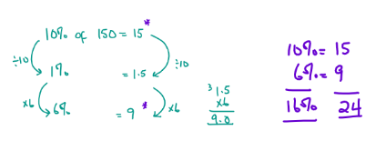

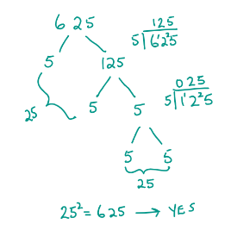
9. Is 625 a square number?
(Show your workings)

10. A farmer has 90 animals. 3/10 are cows, 2/3 are goats while the rest are rabbits. How many rabbits does the farmer have?
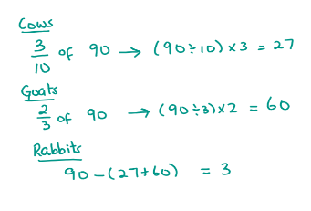

11. Which of these would be an acute angle?
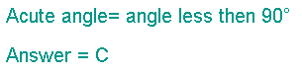
- 90º
- 120º
- 225º
- 35º
- 180º
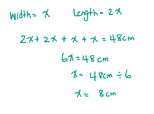
12. The length of a rectangle is twice its width. If its perimeter is 48cm, what is its width?

Need more practice? Why not try our FREE sample Online papers.
https://smart-stepz.com/free-learning-resources/

