Analogies
The 2 images on the left demonstrate a relationship between them Choose from A-E, on the right side of the vertical line, which demonstrates the same relationship, with the test shape.
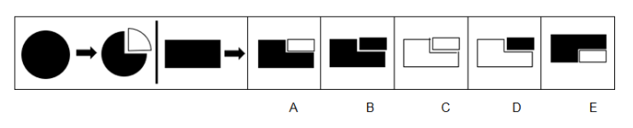
1.
2.
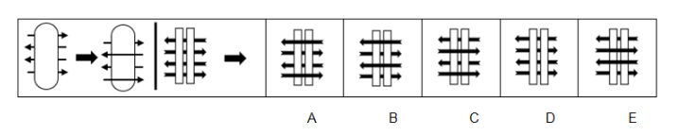

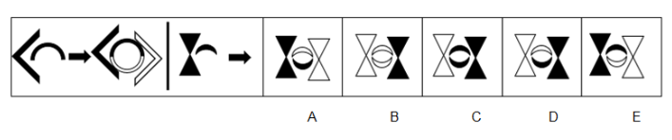
3.
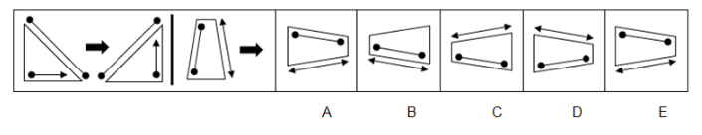
4.
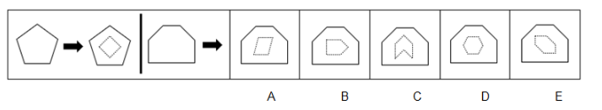
5.

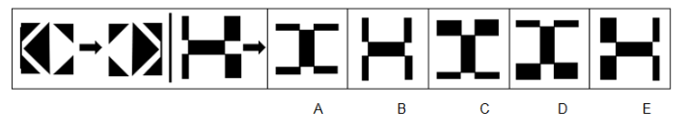
6.

Need more practice? Why not try our FREE sample Online papers.
https://smart-stepz.com/free-learning-resources/

