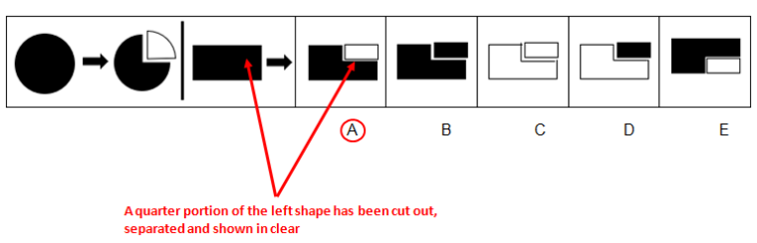
1.

2.
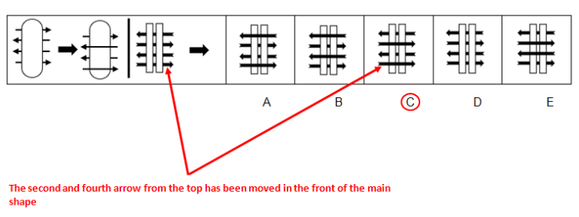

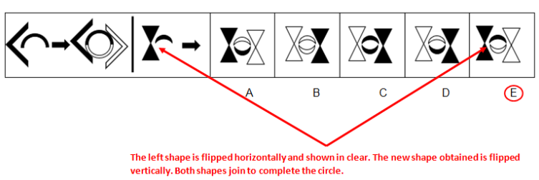
3.

4.
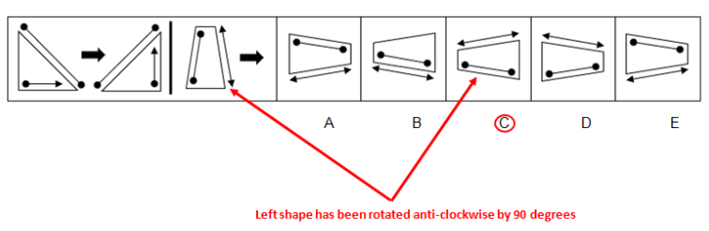

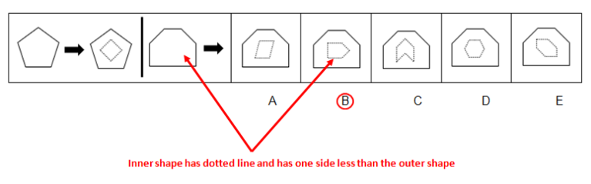
5.

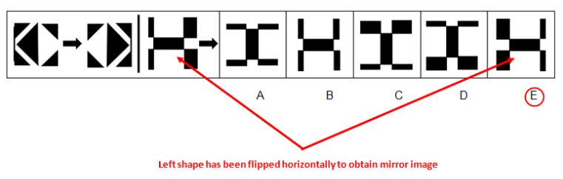
6.

Need more practice? Why not try our FREE sample Online papers.
https://smart-stepz.com/free-learning-resources/

